

**CS 319 - Object-Oriented Software Engineering**

**Final Report Second Iteration**

**Instructor: Eray Tüzün**

**Project Name: The Wall**

**Group 3E**

Erdem Ege Maraşlı - 21602156

Ayça Begüm Taşçıoğlu - 21600907

Alperen Koca - 21502810

Hammad Malik – 21600468

Ensar Kaya - 21502089

**Contents**

**1.Changes in Implementation 2**

1.1 Changes in Business Layer 2

1.2 Changes in Presentation Layer 3

**2. User Guide** **4**

2.1 System Requirements and Installation 4

2.2 Game Units 4

2.3 Controls 5

2.4 Overview 5

**3. Game Screenshots 6**

**4. Work Allocation 15**

**1. Changes in the implementation**

**1.1 Changes in the Business Layer**

**Settings class :** Setting class is recreated and implemented based on the new themes.

**Game class :** A new variable “int theme” is added to understand the desired theme of the game. Also a new variable “int mode” is added. This is for to decide whether game mode will be provided based on the user decision. The mode can be 0 to 4.

-If mode is zero than a classical mode game will be created,

-If mode is 1 than a developer mode (creator) game will be created,

-If mode is 2 a challenge mode game will be created,

-If mode is 3 than a campaign mode game will be created,

-If mode is 4 than a developer mode (already designed map player) game will be created.

**GameUnits class :** Game units such as blue knights and red knights are now presented in Potterhead Theme: blue knights as Harry, Hermione, or Ron, and red knight as Voldemort and death eatars; in Game of Thrones Theme: blue knights as Arya Stark, Jon Snow, or Khaleesi, and red knight as Night King.

**GameBoard class :** Some new methods added to this class. isValidMove method which controls if the desired move is valid or not. makeMove method to place the unit properly and update the map if move is valid. Also some minor changes implemened, which are not changed the logic of the game.

**MouseListener class :** Some minor changes implemented according to the GameBoard class.

**1.3 Changes in Presentation Layer**

There are various panels added such as

**CampaingSelectionPanel**: A panel which provide user to select campaign mode, it can be Harry Potter Campaign (a game which is shaped with Harry Potter’s story flow) or Game of Thrones Campaign ( a game which is shaped with Game of Thrones’s story flow).

**DesignedMapSelection**: A panel which provide user to select a map which is already designed by other users of the game.

**HowToPlayScreen**: a panel which provide user a brief introduction about how to play the game.

**LoginScreen**: a panel which provide user to log in. This panel is using for developer mode. While users log in to the game, they can either create their own map or play with already designed maps.

**SignUpScreen**: a panel which provide user to sign up. This panel is using for developer mode. While users sign up to the game than they log in after that, they can either create their own map or play with already designed maps.

## **2. User Guide**

## **2.1 System Requirements and Installation**

The game will be implemented and to be able to run on Java. Therefore, a computer with operating system and java system will be adequate. The computer should be able to compile and run the files with the extension of “.java”. Java is independent of platform, namely Java is operable independently from the operating system. Java’s system requirements are enough to run the game which is stated on here:“<https://java.com/tr/download/help/sysreq.xml>”. For background music of the game JLayer 1.0.1 needed to be download you can found the download link on here:“<http://www.javazoom.net/javalayer/sources.html>”

## **2.2 Game Units**

**Wall :** This game object has 4 different type. Walls are taken and placed by the player to the complete the game.

**Castle :** This game objects needed to be contain in the walls to complete the game.

**Blue Knights :** This game objects needed to be contain in the walls to complete the game.

**Red Knights :** This game objects needed to be outside of the walls to complete the game.

## 

## **2.3 Controls**

**Mouse Left Click :** To take the desired game unit such as knights, castle and the walls for the developer mode, only walls for other modes. After User takes the game unit he can click again to place the unit.

**Mouse Right Click :** Rotates the selected wall.

**Note :** Buttons works with mouse left click and also a keyboard used for text fields.

## **2.4 Overview**

● When user selects to play game, user can select the game type they desire by clicking the corresponding button.

● In order to use the online features “The Wall” offers, users are obligated to login to their private accounts. To login, users should provide their information and click to the login button.

● The back button exists in the every frame of the game and clicking on it will result in going to the previous frame..

● “The settings” allows users to adjust the volume of background music. Also players can change the theme according to given options, such as, harry potter theme and game of thrones theme. When player changes theme; music, background and units will be change accordingly.

**3. Game Screenshots**

**3.1 Main Screen**

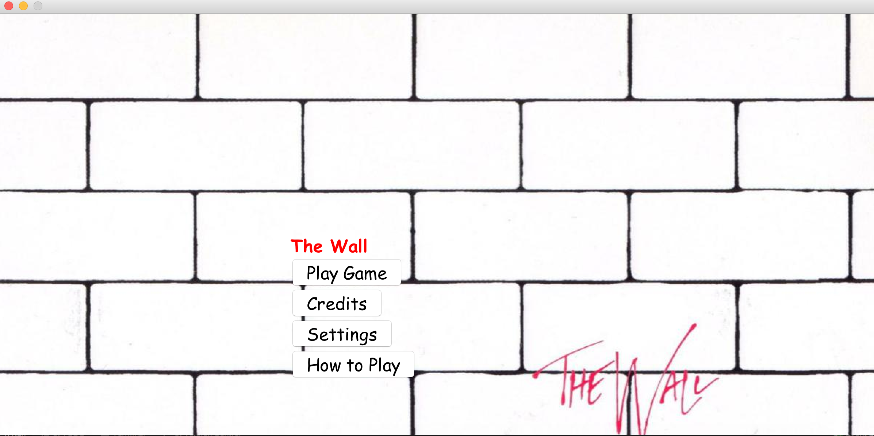

**3.2 Credits Screen** 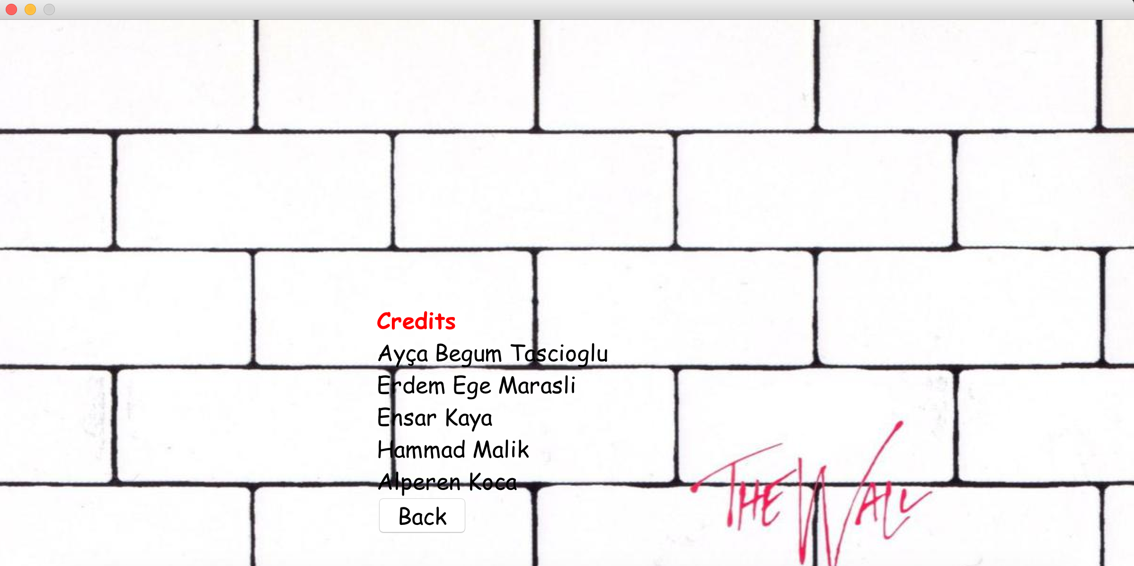

**3.3 Settings Screen - (Harry Potter Theme is selected)**

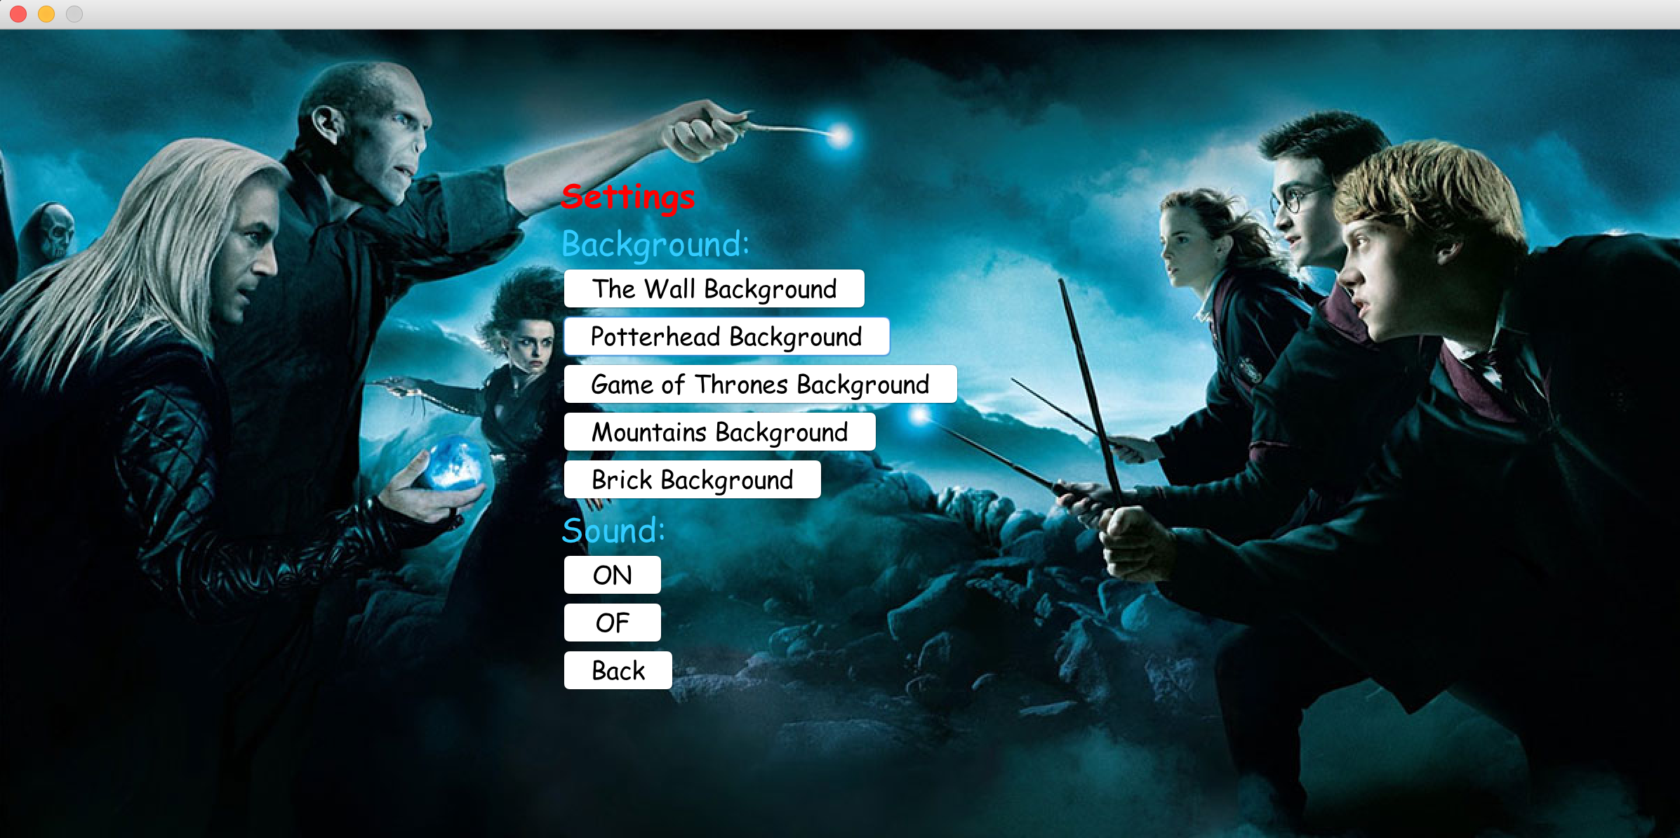

**3.4 Play Screen** 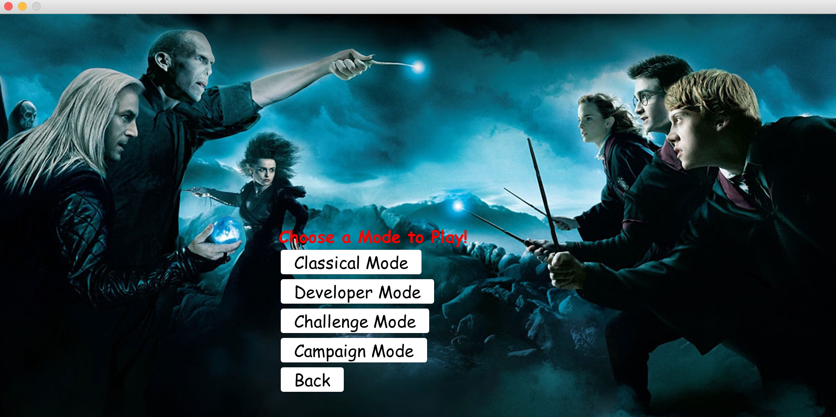

**3.5 Level Selection Screen in Classical Mode**

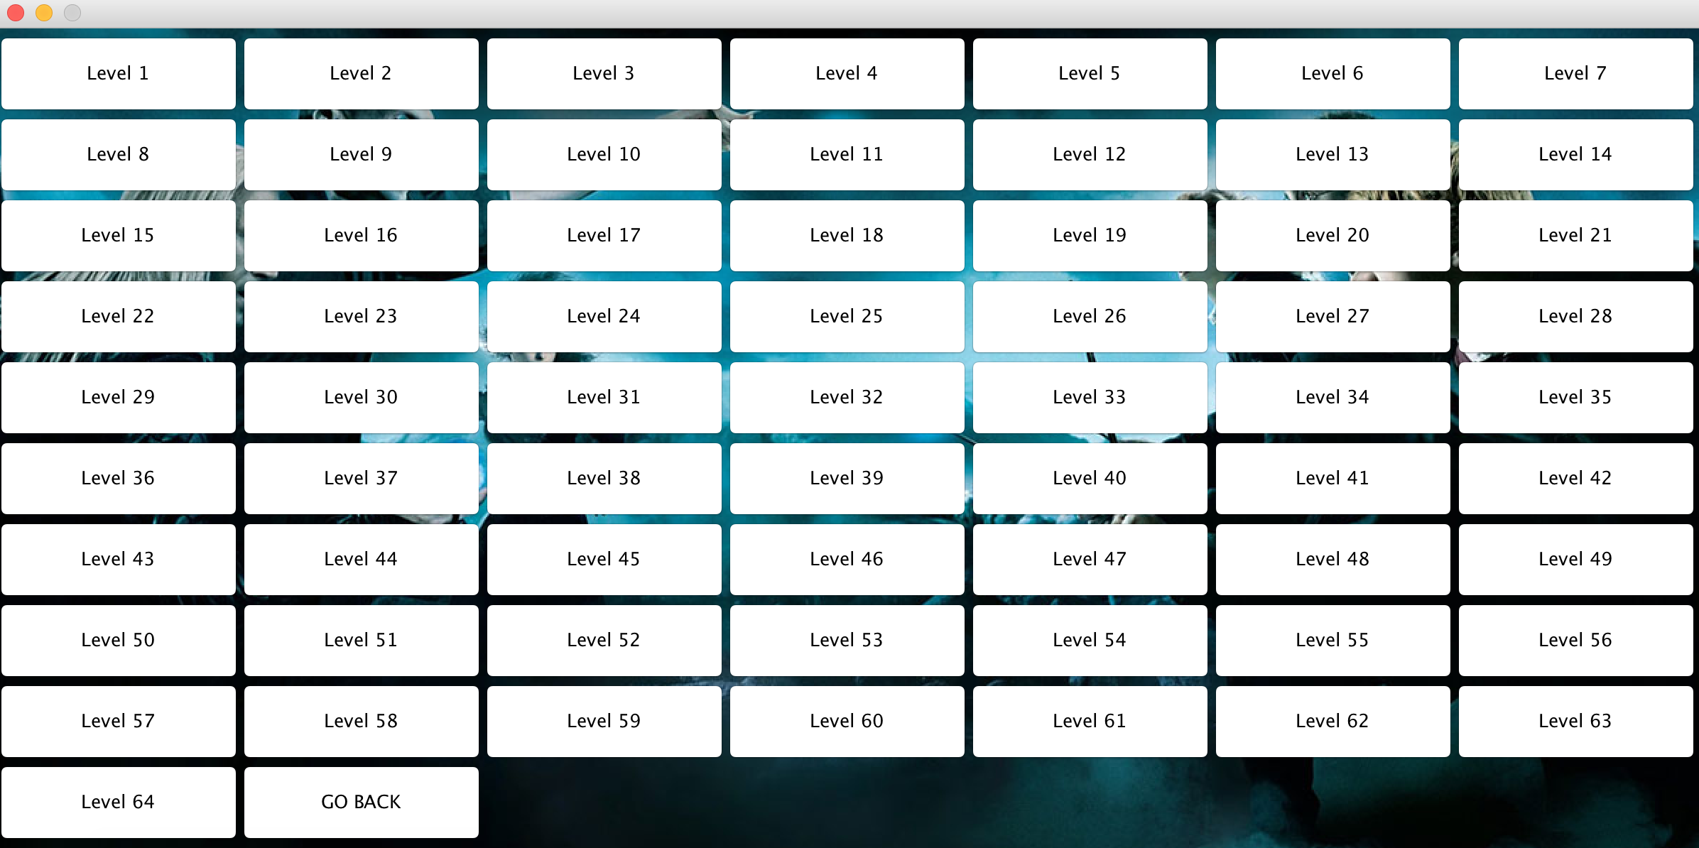

**3.6 Game Screen in Classical Mode**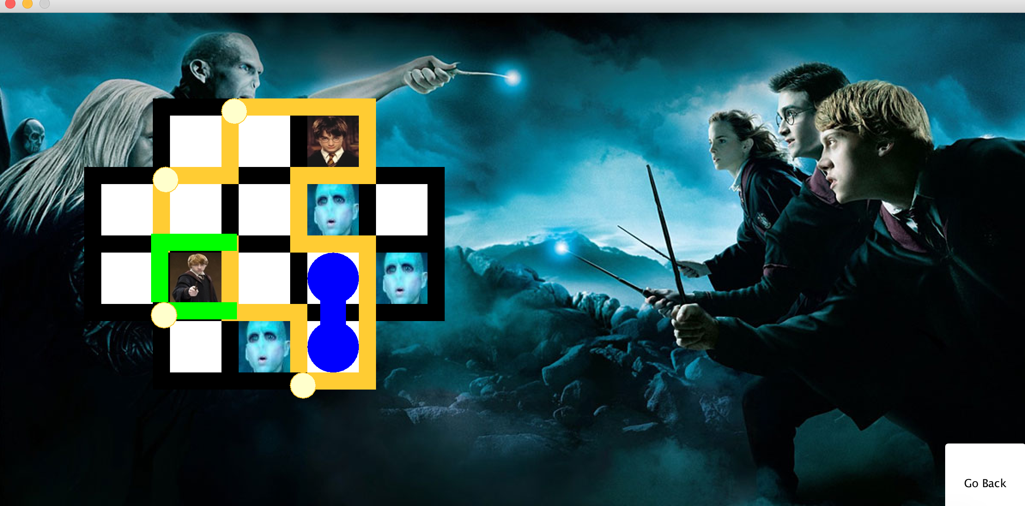

**3.7 LevelPassed popup in Classical Mode**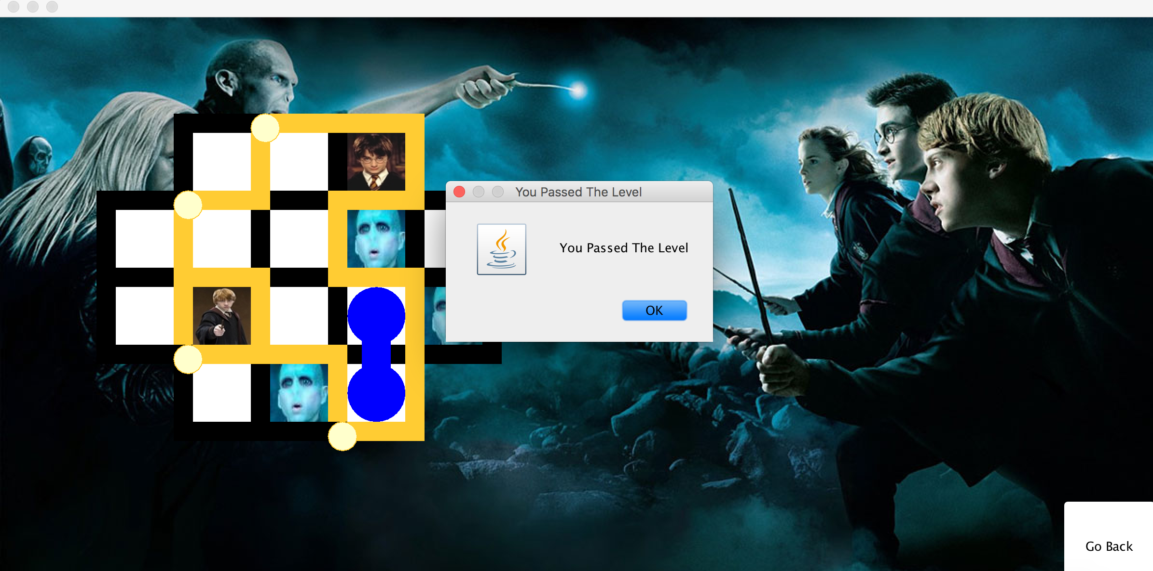

**3.8 Developer Mode Login Screen**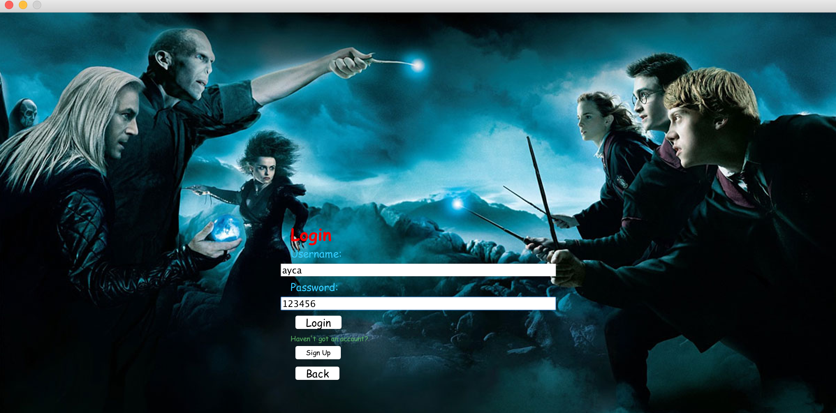

**3.9 Developer Mode SignUp Screen**

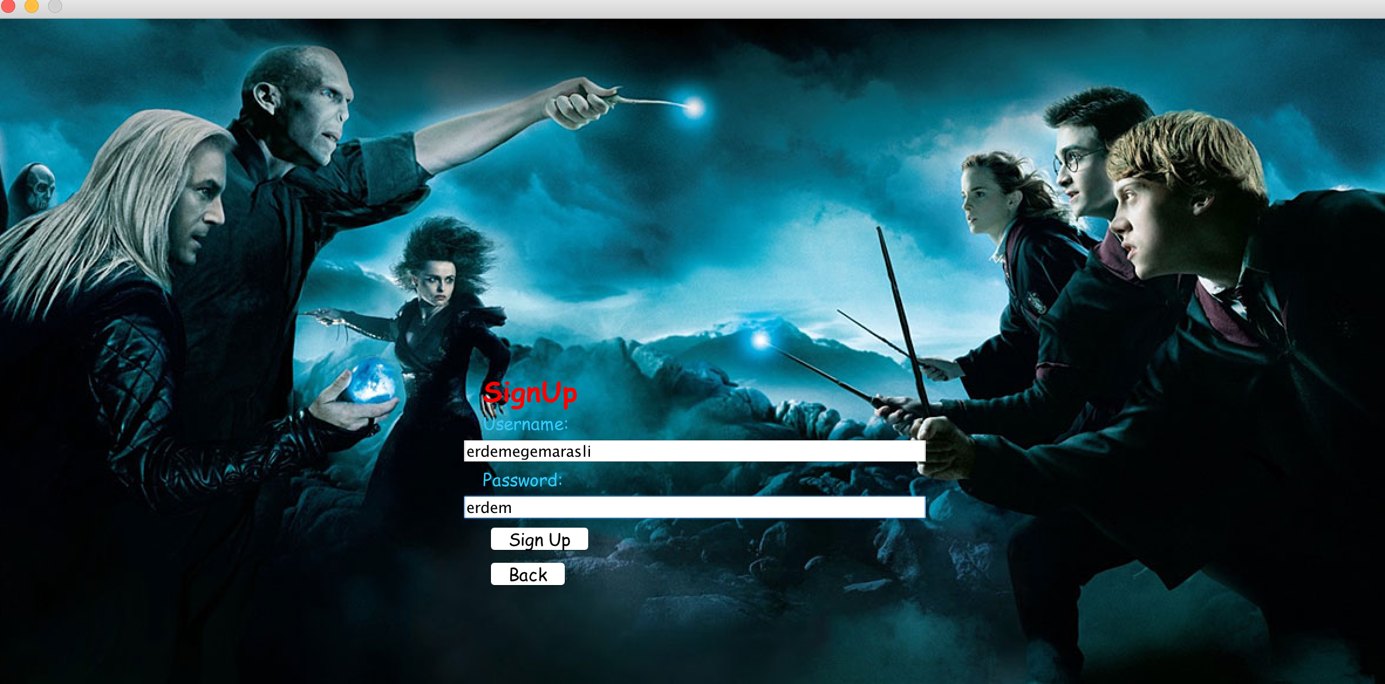

**3.10 Developer Mode Selection** 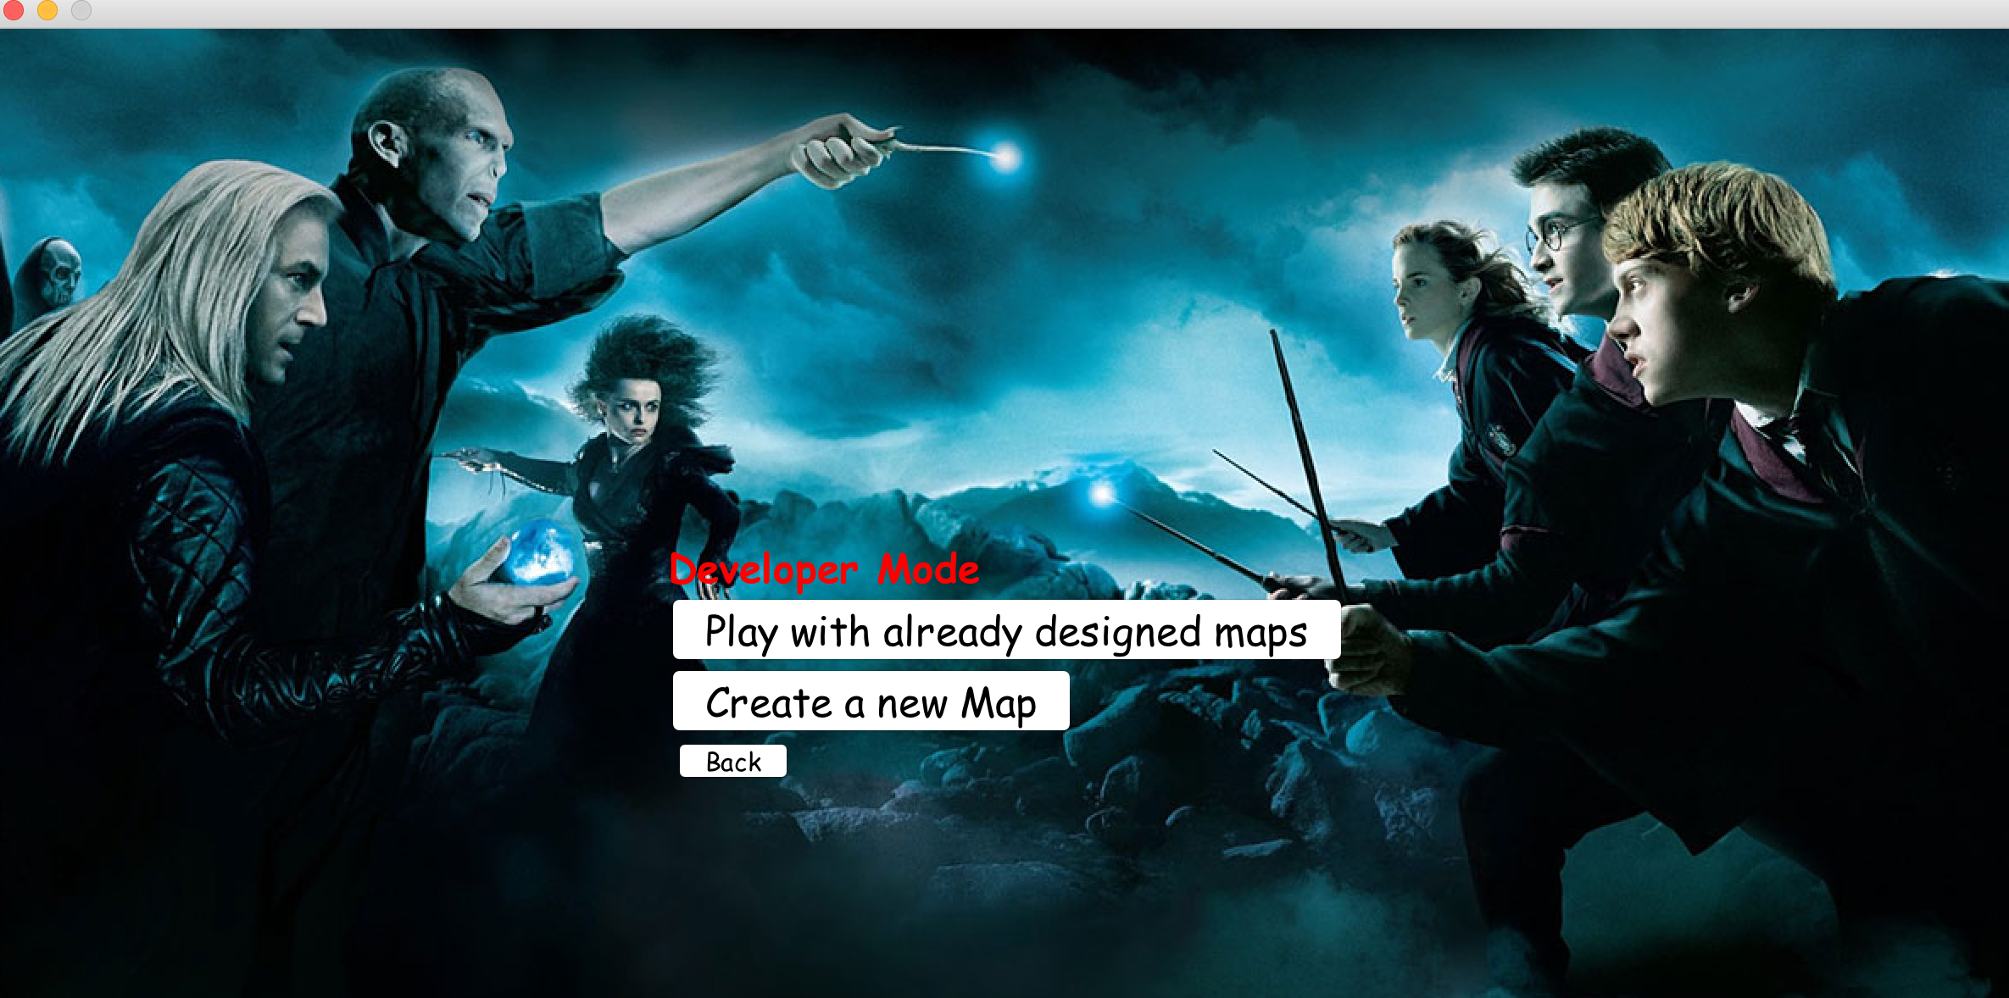

**3.11 Designed Map Selection Screen**

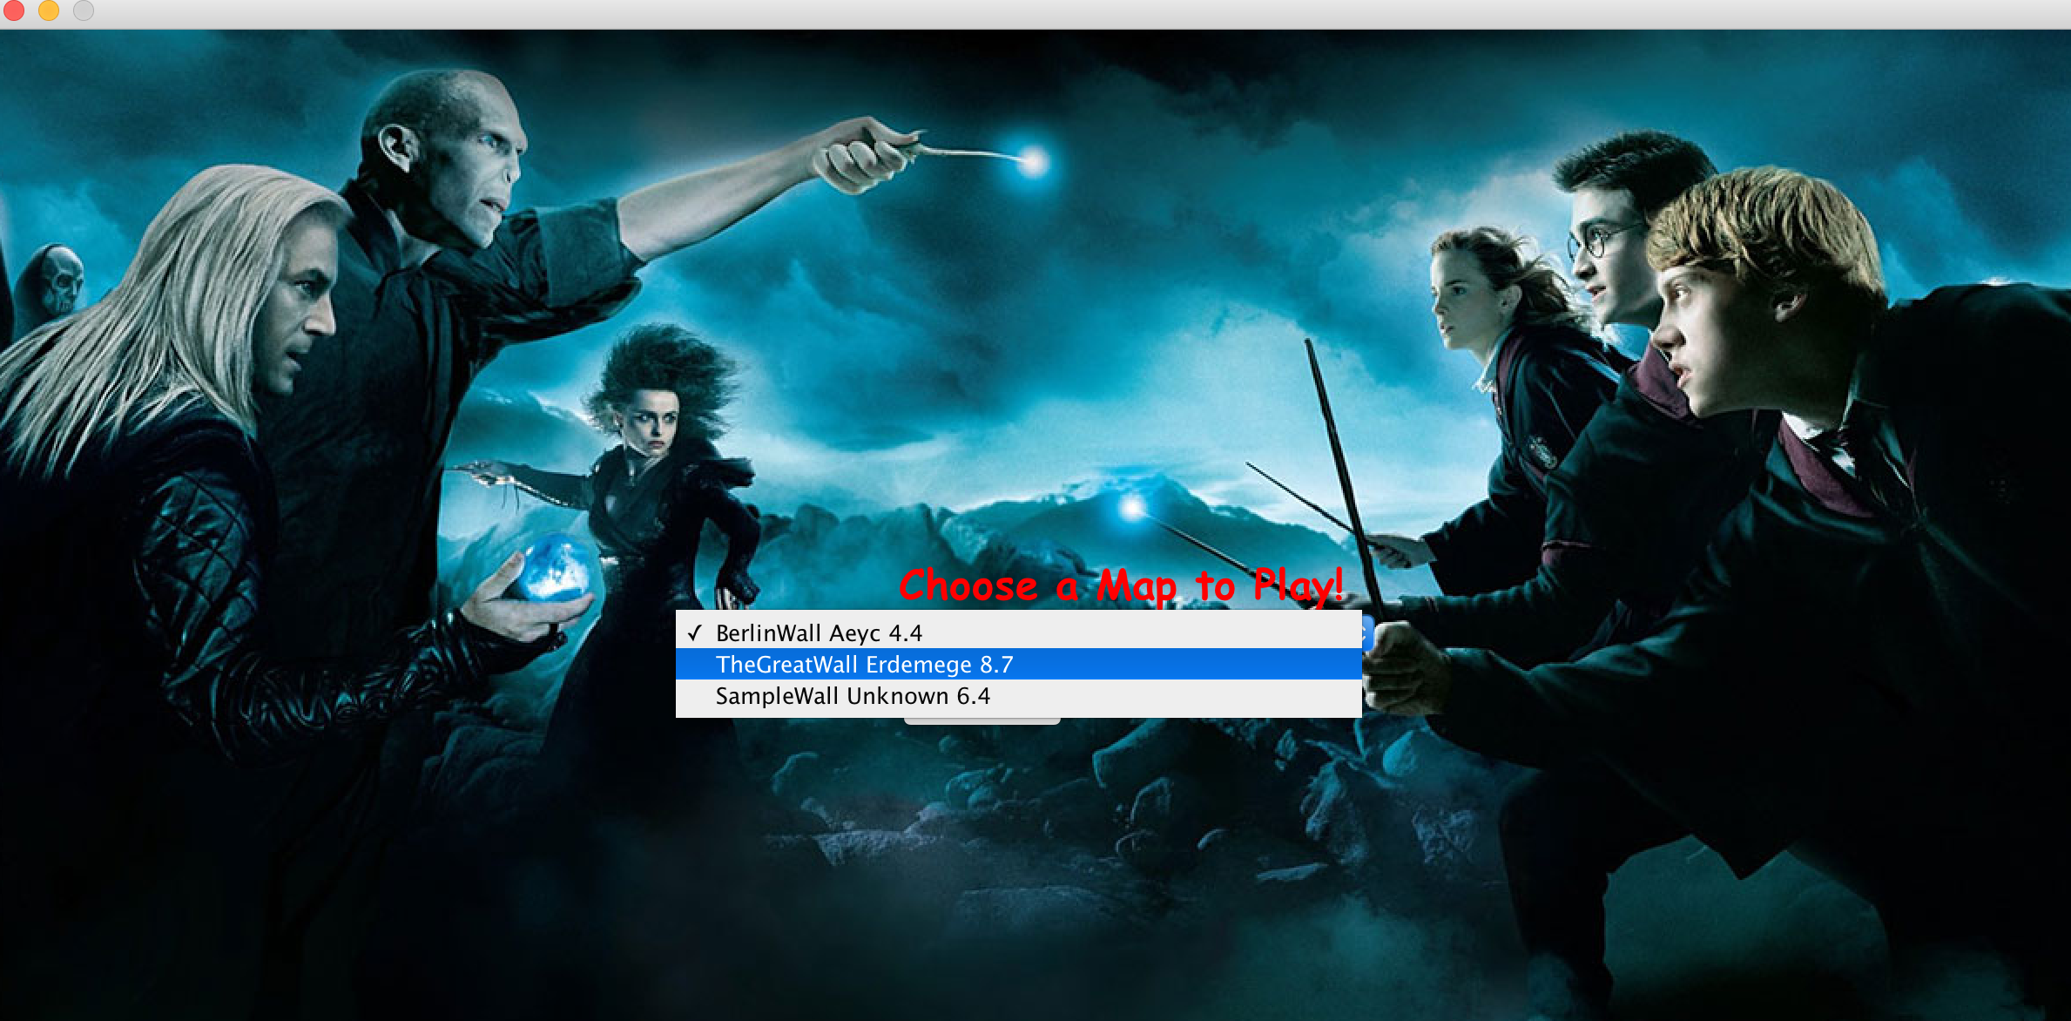

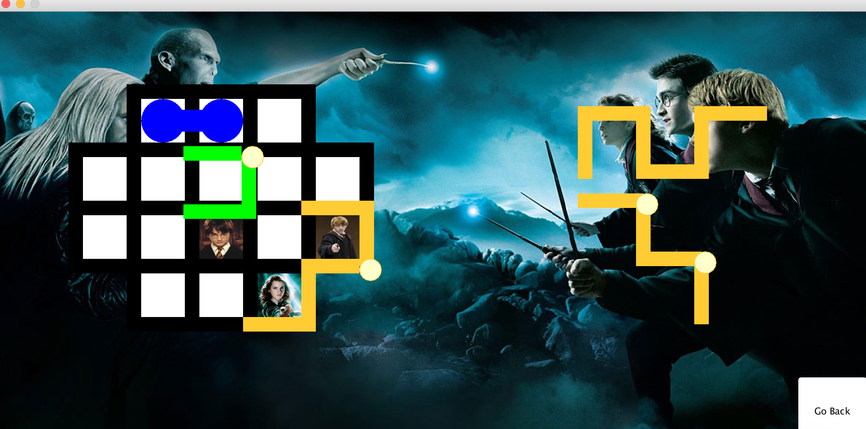

**3.12 Create Map Screen**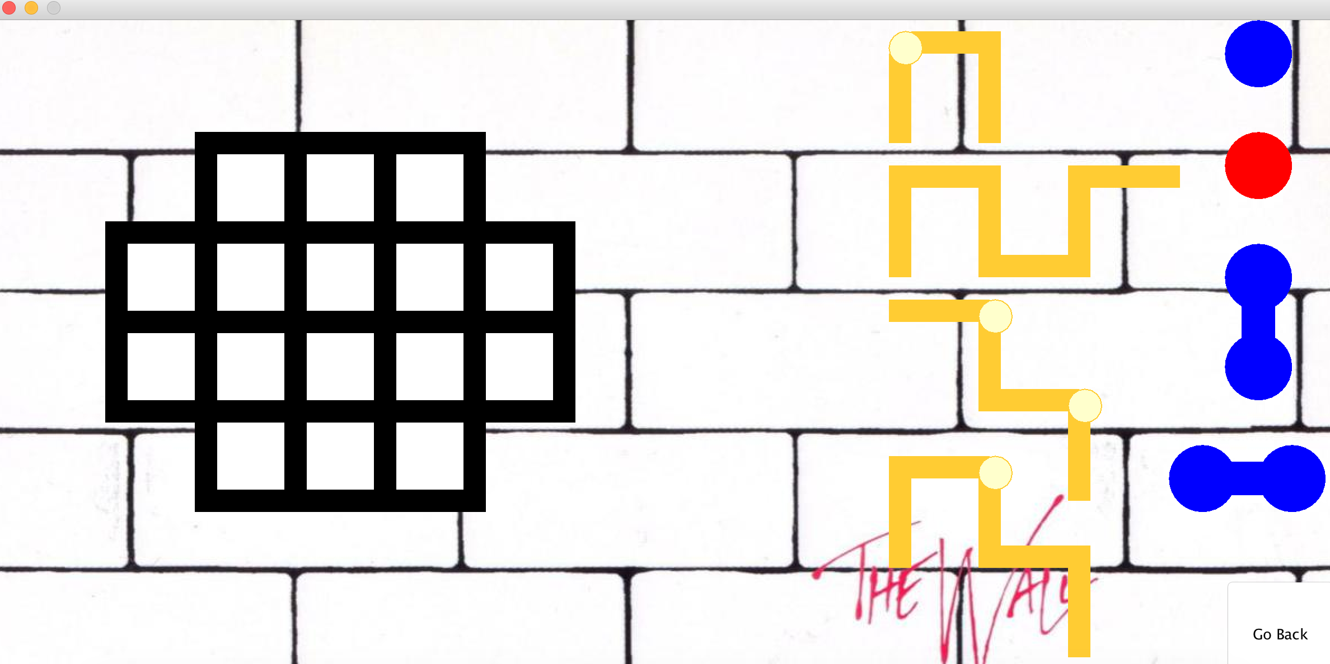

**3.13 Game Screen in Challenge Mode**

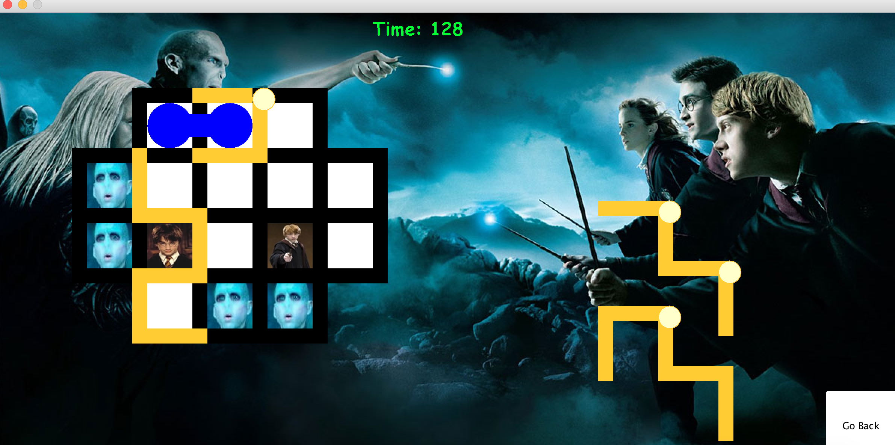

**3.14 Campaign Mode CampaignSelection Screen**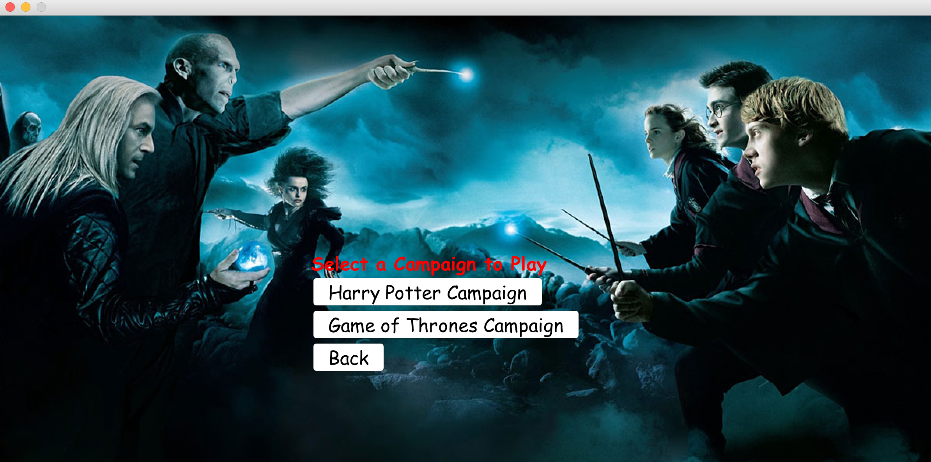

**3.15 Campaign Mode Game Screen in Harry Potter Campaign**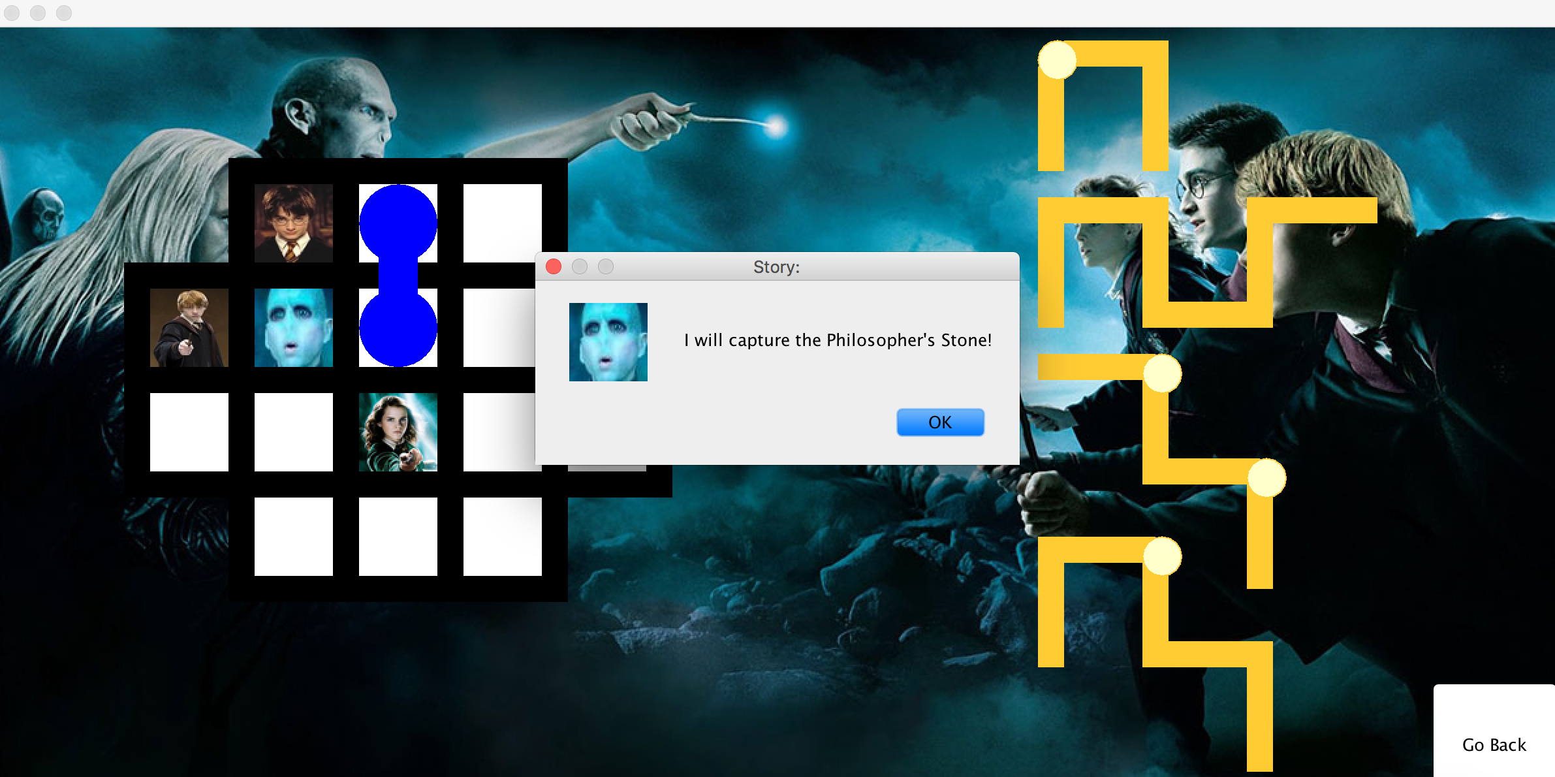

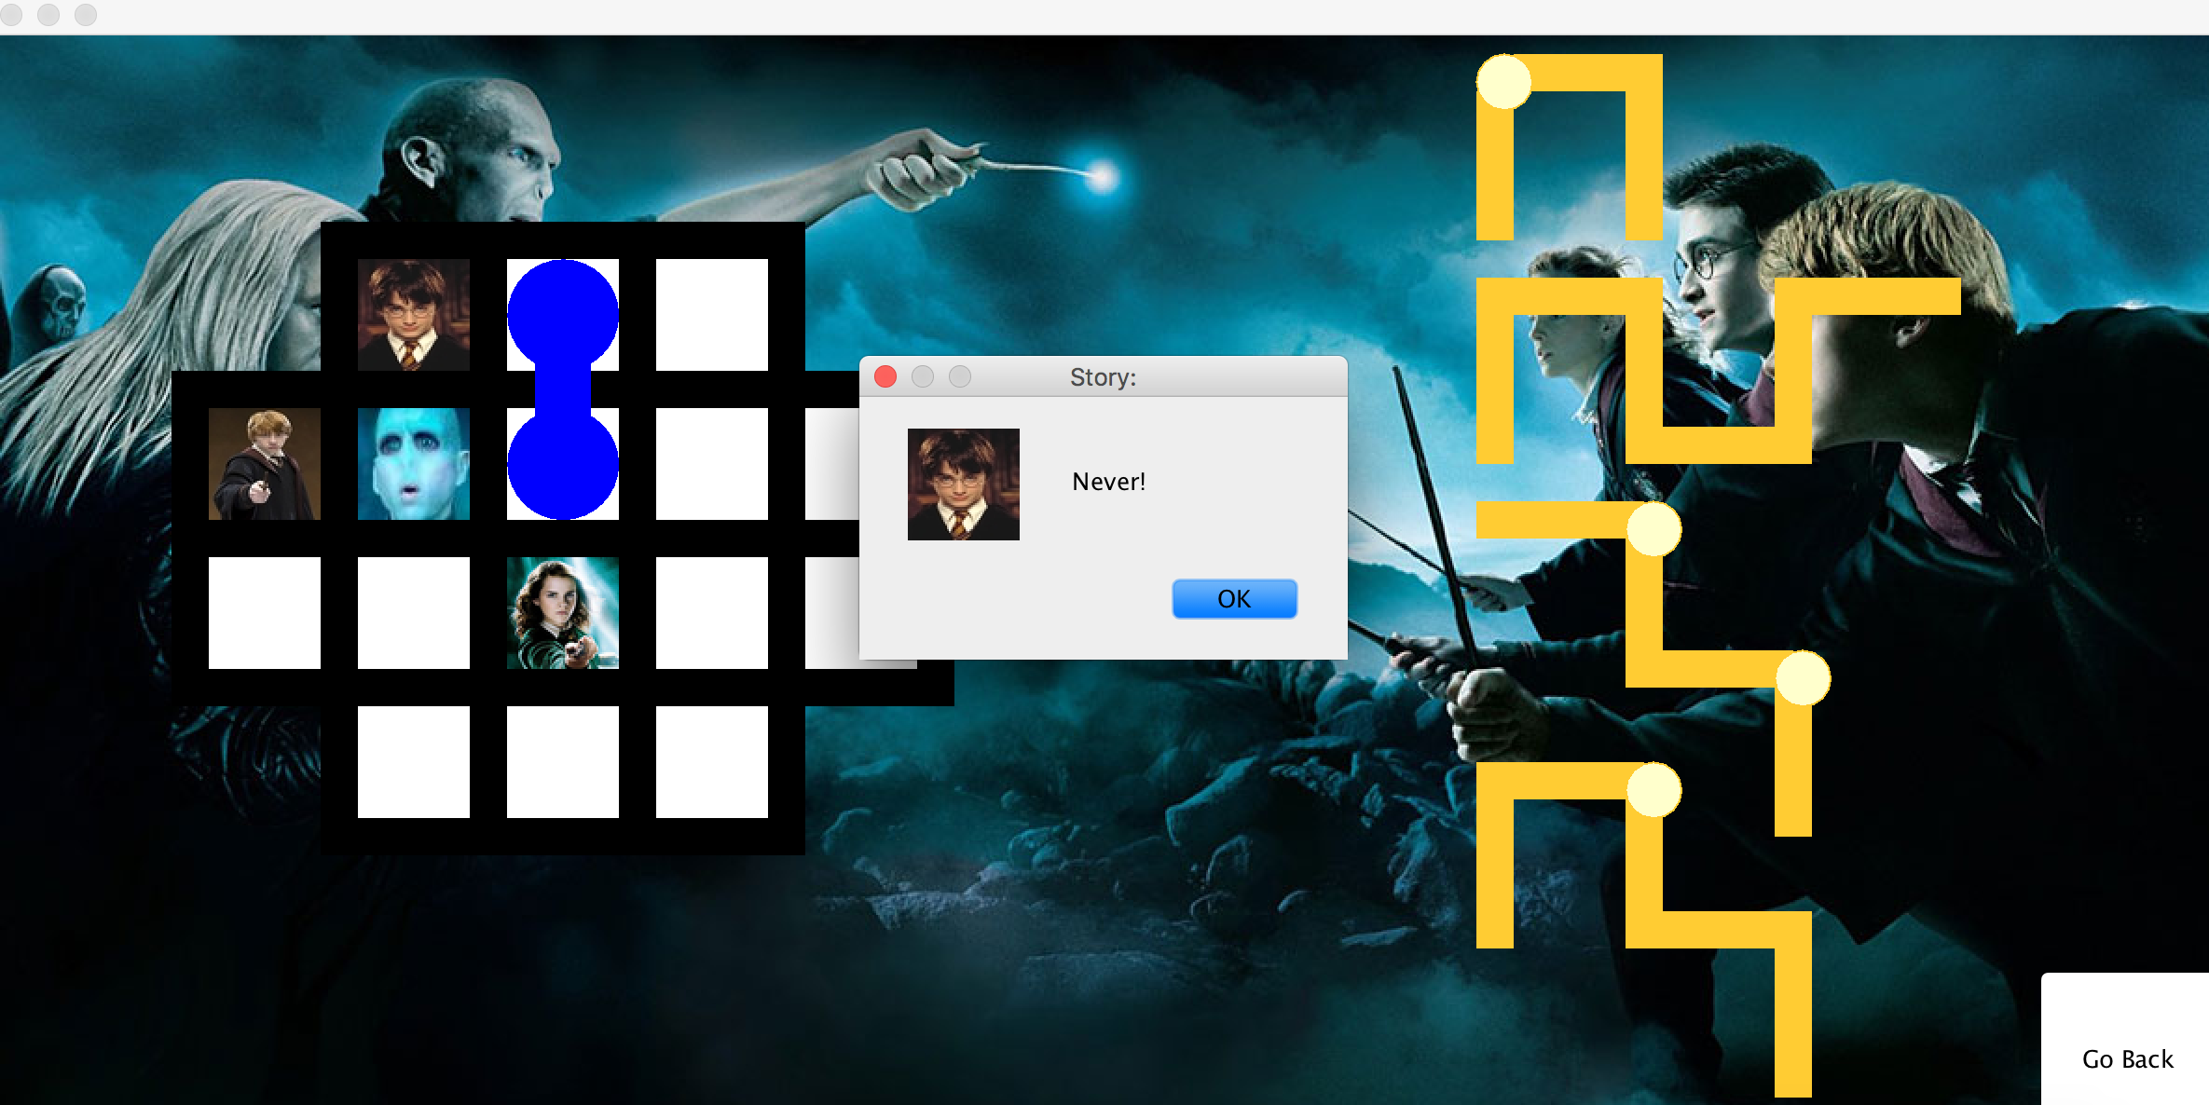

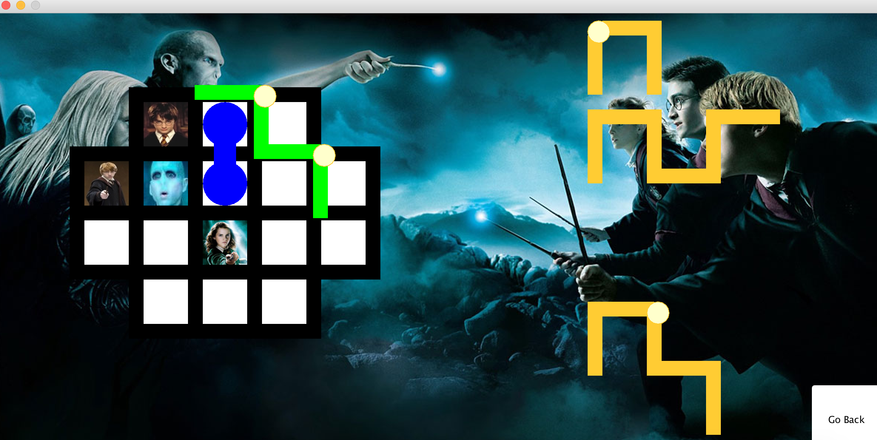

**3.16 Campaign Mode Game Screen in Game of Thrones Campaign**

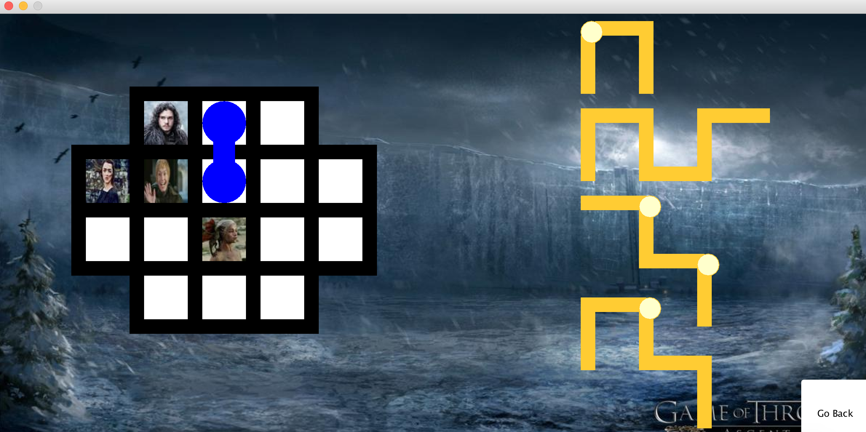

**4. Work Allocation**

**Ayca Begum Tascioglu:** Business & Presentation Layer Design and Implementation. Activity diagram, class diagram, mock ups and descriptions in analysis report. Business & presentation layer diagrams and descriptions in design report and whole final report second iteration.

**Erdem Ege Marasli:** Business & Presentation Layer Design and Implementation. Sequence, class diagrams and descriptions in analysis report. Business & presentation layer diagrams and descriptions in design report and whole final report second iteration.

**Ensar Kaya:** DataLayerDesign and Implementation.Use case & state diagrams and descriptions in analysis report. DataLayer diagrams and descriptions in design report.

**Hammad Malik:** Sound Manager Class. Introduction part in analysis draft report. Game Entities Diagram in Design Report Draft.

**Alperen Koca:** Introduction part in analysis draft report. Game Entities Diagram in Design Report Draft.